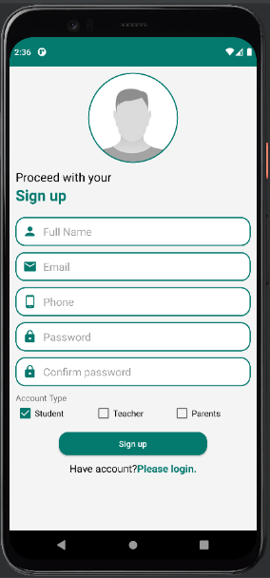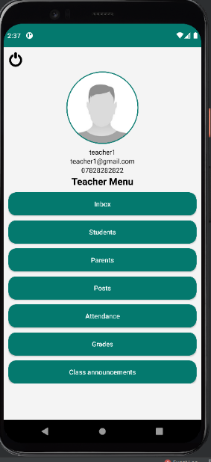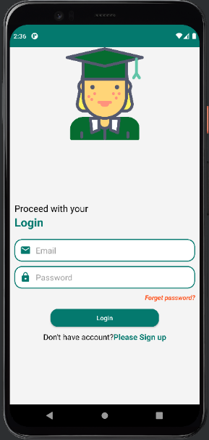

Teacher menu for grades where can assign or change the grade and could add new section for assignment

The parent account inbox, are the last persons contacted by the parent showed in the inbox

As a parent/student they could only view the grades

As a student/parent they could only view the attendance

Parent profile, where could contact teachers/other parents this feature is available only for parents

The share id from student profile need to be shared with parent to create parent account

Pop-up notification where only the teacher can send a notification in case of emergency

Teacher could mark the student present/absent by ticking the box and then submitting

On the forum teachers/parent could post by pressing the button on the right side.

Typical message area where teacher and a student/parent could talk.

Inbox of a teacher where can contact students/parents

Teacher menu with all buttons

All the sections has to be filled and tick the type of the account in order to create account

The teacher/student/parent has to put the details in to connect